|  |  |  |  |  |  |
| --- | --- | --- | --- | --- | --- |
| **Asignatura:** | **INGLES** | **Docente:** | **Alexandra Lavado Sánchez** | | |
| **Nombre estudiante:** |  | **Curso:** | **401** | **Fecha:** |  |

**Read and Answer the questions:**

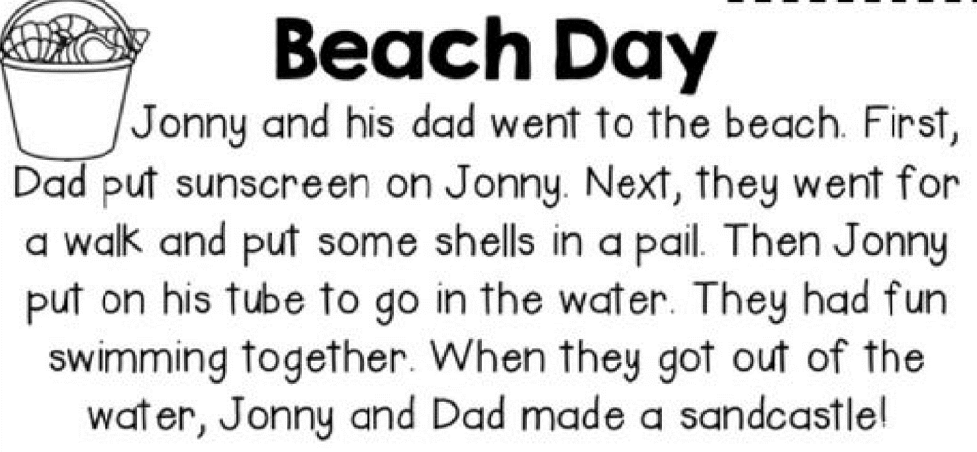

1. Color the genre of this story:



1. Sequence the events. Write 1,2,3,4,5,6:

* _______Jonny and Dad Walked and put shells in a pail
* _______Jonny and Dad went to the beach
* _______Jonny put on his tuve
* _______Dad put sunscreen on Jonny
* _______Jonny and Dad made a sandcastle
* _______They went swimming

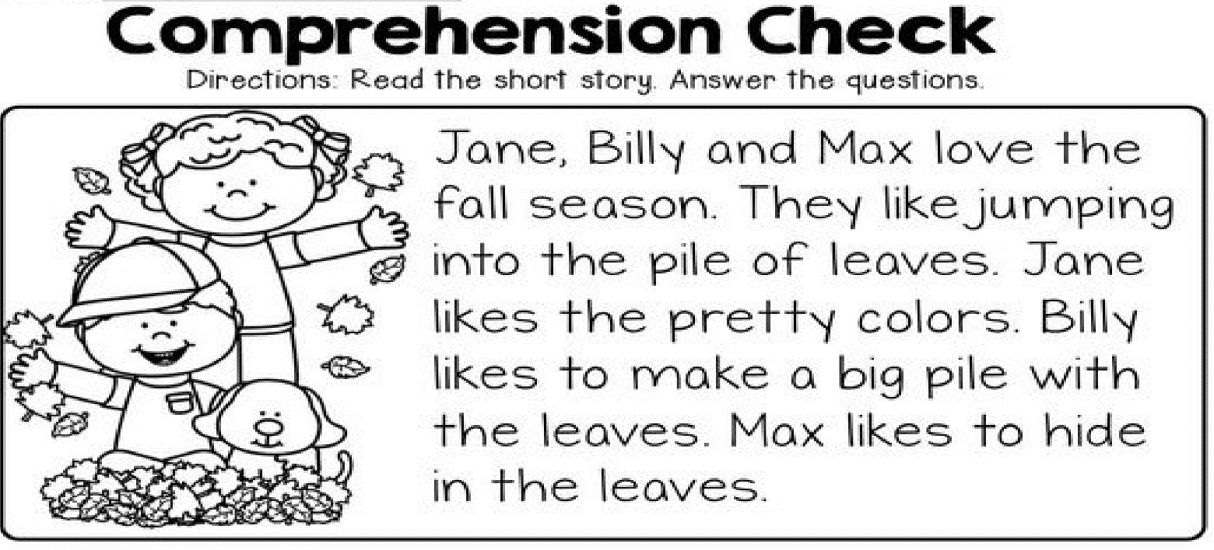

Answer the questions:

1. What season is it?

________________________________________________________________

1. Who likes to hide in the leaves?

__________________________________________________________________

1. What does Billy like to do?

__________________________________________________________________

1. What color do you think the leave are?

__________________________________________________________________